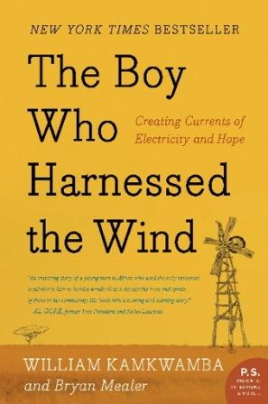
Reading Schedule
The Boy Who Harnessed
the Wind
Chapters 1-4, pp. 1-78
Due Tuesday, 9/25
Chapters 5- 8, pp. 79-159
Due Thursday, 10/11
Chapters 9-12, pp. 160-222
Due Tuesday, 10/23
Chapters 13-end (including Epilogue), pp. 223-286
Due Tuesday, 11/6
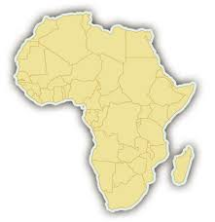
Reading Schedule
The Boy Who Harnessed
the Wind
Chapters 1-4, pp. 1-78
Due Tuesday, 9/25
Chapters 5- 8, pp. 79-159
Due Thursday, 10/11
Chapters 9-12, pp. 160-222
Due Tuesday, 10/23
Chapters 13-end (including Epilogue), pp. 223-286
Due Tuesday, 11/6
Reading Schedule
The Boy Who Harnessed
the Wind
Chapters 1-4, pp. 1-78
Due Tuesday, 9/25
Chapters 5- 8, pp. 79-159
Due Thursday, 10/11
Chapters 9-12, pp. 160-222
Due Tuesday, 10/23
Chapters 13-end (including Epilogue), pp. 223-286
Due Tuesday, 11/6
Reading Schedule
The Boy Who Harnessed
the Wind
Chapters 1-4, pp. 1-78
Due Tuesday, 9/25
Chapters 5- 8, pp. 79-159
Due Thursday, 10/11
Chapters 9-12, pp. 160-222
Due Tuesday, 10/23
Chapters 13-end (including Epilogue), pp. 223-286
Due Tuesday, 11/6
Dictionary of Malawi Words
Azungu - white man or foreigners
Bawo – a game, like mancala
Bo – short for bon jour (hello)
Chamba – marijuana
Charo – Chief, ruler of all the land
Dambos – grassy marshes in the valley; grow tobacco seedlings there
Dowe – Green maize; ripe corn
Gaga – maize chaff
Ganyu – day work
Gule Wamkulu - secret gang of dancers said to be spirits of dead ancestors
Jumbos – plastic garbage bags
Kachaso - strong maize liquor
Kenyenya – fried food
Kwacha notes – money
Maize – white corn
Mangolomera – a form of magic that delivered super human strength
Misala – crazy
Mphala – home for unmarried boys; like a clubhouse
Nsima – dough-like porridge made from maize
Phala – maize porridge
Sin’anga – witch doctor
Waganyu – People who sought day work; poor
Dictionary of Malawi Words
Azungu - white man or foreigners
Bawo – a game, like mancala
Bo – short for bon jour (hello)
Chamba – marijuana
Charo – Chief, ruler of all the land
Dambos – grassy marshes in the valley; grow tobacco seedlings there
Dowe – Green maize; ripe corn
Gaga – maize chaff
Ganyu – day work
Gule Wamkulu - secret gang of dancers said to be spirits of dead ancestors
Jumbos – plastic garbage bags
Kachaso - strong maize liquor
Kenyenya – fried food
Kwacha notes – money
Maize – white corn
Mangolomera – a form of magic that delivered super human strength
Misala – crazy
Mphala – home for unmarried boys; like a clubhouse
Nsima – dough-like porridge made from maize
Phala – maize porridge
Sin’anga – witch doctor
Waganyu – People who sought day work; poor
Dictionary of Malawi Words
Azungu - white man or foreigners
Bawo – a game, like mancala
Bo – short for bon jour (hello)
Chamba – marijuana
Charo – Chief, ruler of all the land
Dambos – grassy marshes in the valley; grow tobacco seedlings there
Dowe – Green maize; ripe corn
Gaga – maize chaff
Ganyu – day work
Gule Wamkulu - secret gang of dancers said to be spirits of dead ancestors
Jumbos – plastic garbage bags
Kachaso - strong maize liquor
Kenyenya – fried food
Kwacha notes – money
Maize – white corn
Mangolomera – a form of magic that delivered super human strength
Misala – crazy
Mphala – home for unmarried boys; like a clubhouse
Nsima – dough-like porridge made from maize
Phala – maize porridge
Sin’anga – witch doctor
Waganyu – People who sought day work; poor
Dictionary of Malawi Words
Azungu - white man or foreigners
Bawo – a game, like mancala
Bo – short for bon jour (hello)
Chamba – marijuana
Charo – Chief, ruler of all the land
Dambos – grassy marshes in the valley; grow tobacco seedlings there
Dowe – Green maize; ripe corn
Gaga – maize chaff
Ganyu – day work
Gule Wamkulu - secret gang of dancers said to be spirits of dead ancestors
Jumbos – plastic garbage bags
Kachaso - strong maize liquor
Kenyenya – fried food
Kwacha notes – money
Maize – white corn
Mangolomera – a form of magic that delivered super human strength
Misala – crazy
Mphala – home for unmarried boys; like a clubhouse
Nsima – dough-like porridge made from maize
Phala – maize porridge
Sin’anga – witch doctor
Waganyu – People who sought day work; poor

