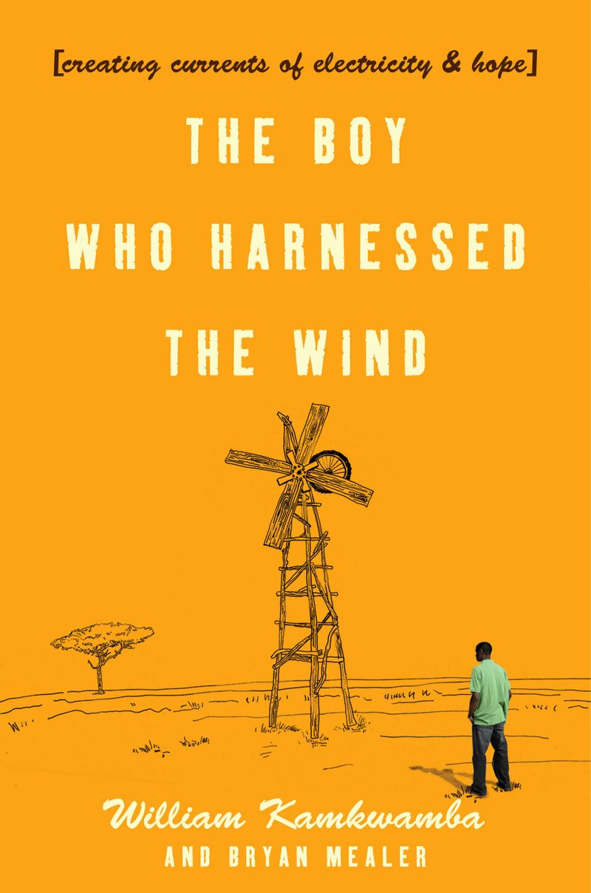

The Boy Who Harnessed the Wind Mini-Research Project
The Boy Who Harnessed the Wind is a non-fiction book that tells the story of a young boy growing up in a remote village in Malawi who through his commitment and creativity is able to save his village from the ravages of famine. It is also a compelling story about fate, determination, responsibility, and life. As you read the book, you will be introduced to a culture very different from your own. This small research project is designed to enhance your understanding of the book, the characters, and the culture of Malawi.
For this mini-research project, you are asked to investigate one item on the list below. Using at least two reliable sources (not Wikipedia), read about the topic, highlight and take notes on the articles, and prepare a short Powerpoint presentation (no more than 5 slides). Post your presentation in Canvas.
You are the authority. Your job is to teach us all we need to know to fully understand your topic.
Your Powerpoint presentation is due on Use your own words to help your classmates understand the topic you researched and thus better understand The Boy Who Harnessed the Wind.
The last slide in your presentation must include the source information you used, including:
- Author of the article (if the name is given)
- Title of the article
- The source (This could be the title of the magazine or newspaper, the name of the website, or the URL)
- Date it was written
- Date you located the article online

This is a 40 point assignment.
Your Powerpoint presentation does not have to be fancy, but it does have to be accurate, grammatically correct, and clearly written in your own words.

Mini-Research Topics

AIDS epidemic in Africa
- Why is AIDS such a big problem in Africa?
- What is being done to address the problem?
- How effective are the efforts to control AIDS?

Famine in Africa
- Where is famine occurring in Africa?
- How extensive is the problem?
- What are the effects?
- What is being done to address the problems?

Malaria in Africa
- How is malaria transmitted?
- How extensive is the disease?
- What are the treatments?
- How effective are the treatments?

Deforestation in Africa
- What is deforestation?
- Why is it a problem?
- What is being done to address the problem?

Drought in Africa
- What African countries are affected by droughts today?
- How extensive is the problem?
- What has been the effect of the droughts?
- What is being done to address the problems?

Education in Malawi
- What is the literacy rate in Malawi?
- What percentage of children graduate high school?
- What percentage graduate college?
- What is the quality of education?
- Is education readily available to all children?

Underage marriages in Africa
- Why are underage marriages prevalent?
- What are the problems associated with underage marriage?
- What is being done to address the problem?
Marriage rituals in Malawi
- What are the marriage rituals or customs in Malawi?

Government of Malawi
- What type of government is in power in Malawi?
- How effective is the government?
- Is corruption still a problem?

Farming in Malawi
- What percentage of the population makes their living by farming?
- What crops are grown?
- What problems affect the farmers today?
- What is being done to address the problems?

Cholera in Africa
- What is cholera?
- How is it transmitted?
- How is it treated?
- Is it still a problem in Africa?

Magic in the Malawi culture
- How do Malawi citizens feel about magic today?
- What role does it play in their lives?

Moving Windmills Project
- What is the Moving Windmills project?
- What are the goals of the project?
- How successful has it been?
- How can people get involved?

